Priyanka Pravinkumar Sukre

Abstract
- Customer Segmentation
2) Insurance Claim Status
Data Mining Project

Table of Contents
Problem Statement: 3
Introduction: 3
1.1 Read the data and do exploratory data analysis. Describe the data briefly. Interpret the inferences for each. Initial steps like head () .info (), Data Types, etc . Null value check. Distribution plots (histogram) or similar plots for the continuous columns. Box plots, Correlation plots. Appropriate plots for categorical variables. Inferences on each plot. Summary stats, Skewness, Outliers proportion should be discussed, and inferences from above used plots should be there. 3
1.2 Do you think scaling is necessary for clustering in this case? Justify 7
1.3 Apply hierarchical clustering to scaled data. Identify the number of optimum clusters using Dendrogram and briefly describe them 8
1.4 Apply K-Means clustering on scaled data and determine optimum clusters. Apply elbow curve and silhouette score. Explain the results properly. Interpret and write inferences on the finalized clusters. 12
1.5 Describe cluster profiles for the clusters defined. Recommend different promotional strategies for different clusters. 14
Problem Statement 16
Introduction: 16
2.1 Read the data, do the necessary initial steps, and exploratory data analysis (Univariate, Bi-variate, and multivariate analysis). 16
2.2 Data Split: Split the data into test and train, build classification model CART, Random Forest, Artificial Neural Network 22
2.3 Performance Metrics: Comment and Check the performance of Predictions on Train and Test sets using Accuracy, Confusion Matrix, Plot ROC curve and get ROC_AUC score, classification reports for each model. 23
2.4 Final Model: Compare all the models and write an inference which model is best/optimized. 27
2.5 Inference: Based on the whole Analysis, what are the business insights and recommendations. 28

List of Tables :
S No | Table No. | Description
1 | Table 1.1 | Sample Dataset
2 | Table 1.2 | Null Values
3 | Table 1.3 | Statistical Description of the data
4 | Table 1.4 | Sample Scaled Data
5 | Table 1.5 | Sample Cluster data
6 | Table 1.6 | Grouping the Cluster
7 | Table 1.7 | K means Inertia Values
8 | Table 1.8 | K means Cluster Grouping
9 | Table 2.1 | Sample Data set
10 | Table 2.2 | Null Values
11 | Table 2.3 | Statistical Description of the data
12 | Table 2.4 | Sample dataset after assigning feature codes
13 | Table 2.5 | CART Train Confusion Matrix
14 | Table 2.6 | CART Test Confusion Matrix
15 | Table 2.7 | RF Train Confusion Matrix
16 | Table 2.8 | RF Test Confusion Matrix
17 | Table 2.9 | ANN Train Confusion Matrix
18 | Table 2.10 | ANN Test Confusion Matrix
19 | Table 2.11 | Comparison Table of three models
List of Figures:
S No | Fig No. | Description
1 | Fig 1.1 | Data Corelation
2 | Fig 1.2 | Bivariate Analysis Pair Plot
3 | Fig 1.3 | Outliers before Treatment
4 | Fig 1.4 | Outliers after Treatment
5 | Fig 1.5 | Dendrogram
6 | Fig 1.6 | Ward Linkage with Maxclust 3
7 | Fig 1.7 | Ward Linkage with Distance 16
8 | Fig 1.8 | Cluster Analysis
9 | Fig 1.9 | Elbow Curve
10 | Fig 1.10 | K Means Cluster Analysis/Graph
11 | Fig 2.1 | Outliers
12 | Fig 2.2 | Correlation Graph
13 | Fig 2.3 | Pair Plot
14 | Fig 2.4 | CART Train ROC Curve
15 | Fig 2.5 | CART Test ROC Curve
16 | Fig 2.6 | RF Train ROC Curve
17 | Fig 2.7 | RF Test ROC Curve
18 | Fig 2.8 | ANN Train ROC Curve
19 | Fig 2.9 | ANN Test ROC Curve

PROJECT 1:

Problem Statement:
A leading bank wants to develop a customer segmentation to give promotional offers to its customers. They collected a sample that summarizes the activities of users during the past few months. You are given the task to identify the segments based on credit card usage.

Introduction:
The purpose of this assignment is to understand the customer segmentation to give promotional offers to its customers by performing required exploratory data analysis and Data mining concepts of unsupervised learning techniques. This model will help us to identify the customer segmentation for better banking.

Read the data and do exploratory data analysis. Describe the data briefly. Interpret the inferences for each. Initial steps like head () .info (), Data Types, etc . Null value check. Distribution plots (histogram) or similar plots for the continuous columns. Box plots, Correlation plots. Appropriate plots for categorical variables. Inferences on each plot. Summary stats, Skewness, Outliers proportion should be discussed, and inferences from above used plots should be there.

Sample of the dataset:
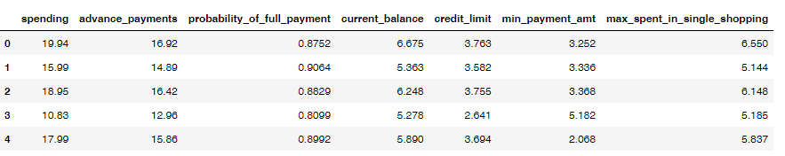
Table 1.1 Dataset of the Sample

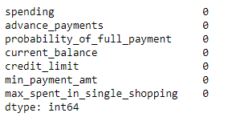
Table 1.2 Null Values
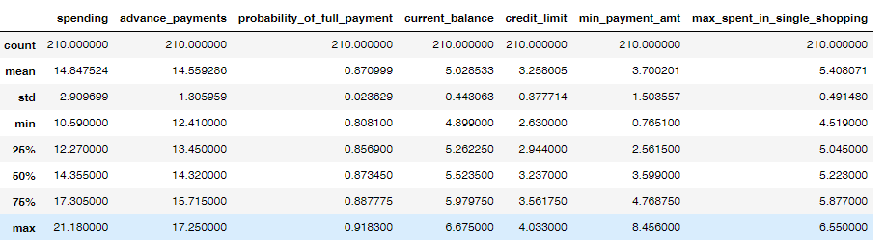
Table 1.3 Statistical Description of the dataset

The dataset contains 210 observations with 7 features
The dataset contains no missing values and duplicate values
The minimum probability of making the full payment stands at 0.80 which is a positive attribute for the bank
It is observed that a meaningful amount is spent at one time purchase within the limit of credit card
Univariate Analysis:

There are 7 numeric data fields in the data
The spending ranges from Rs. 10,590 to Rs. 21,180 and have no outliers
There were few outliers present in the probability of full payment and minimum payment amount
It is observed that most of the customers spent the max amount at one purchase is of Rs. 5,200/- .

Bivariate Analysis:
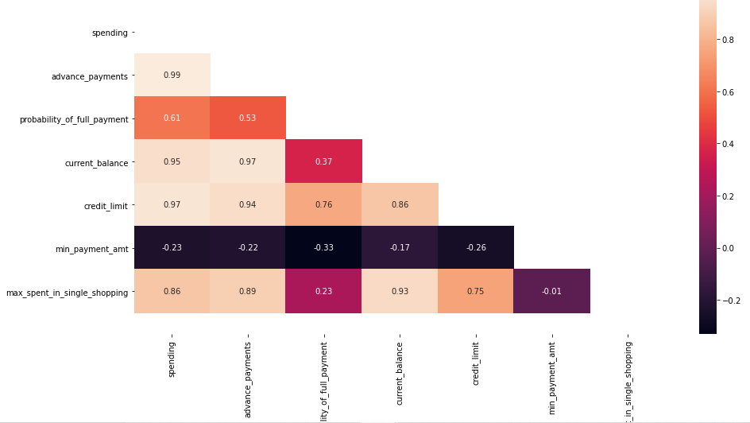
Fig 1.1 Data Correlation

There are considerable number of features that are correlated
Advanced payments show high correlation with spending, current balance and credit limit where as we also can observe the negative correlation of Minimum payment amount with all the features.

Multivariate analysis:
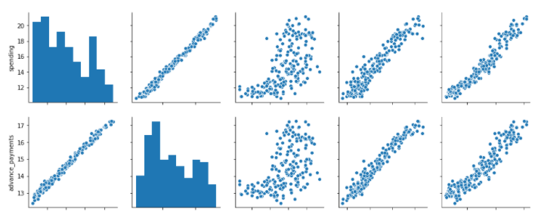
Fig 1.2 Pair Plot
From the Pair plot we can analyze that considerable number of features have positive correlation and each feature is important in defining the business solution.
From all the analysis it is quite evident that all features given in the dataset are equally important to for obtaining proper business solution.
Outliers Treatment:
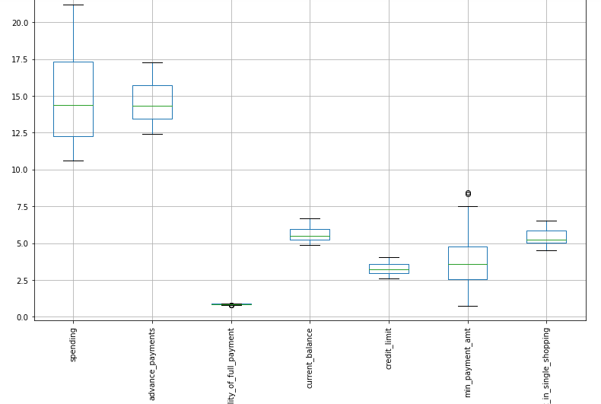
Fig 1.3 Outliers
From the above figure it is quite evident that two features out of 7 features are having outliers i.e., Probability of full payment and Minimum payment amount features. The outliers have been treated for obtaining the better result. The outliers have been treated and the resultant output is shown below:

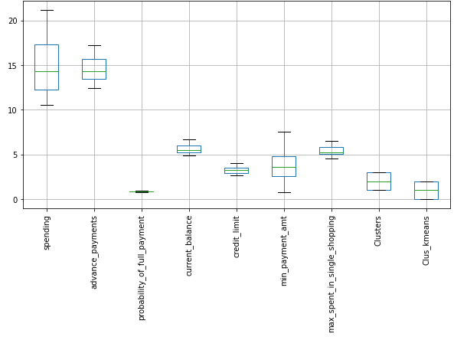
Fig 1.4 Treated Outliers

Do you think scaling is necessary for clustering in this case? Justify

The data needs to be scaled in this case because of the values in the features are all not all in the same degree of valuation. In order to bring the all the values into the same degree valuation scaling needs to be done to the dataset. Some of the features are values in 1000s and other features are valued in 100s. In this case scaling needs to be done. Here the scaling is done using the Z score.
The Z score method transforms the data into a distribution with a mean 0 and the standard deviation of 1. As most of the features in the dataset is almost following the normal distribution the applying Z score for standardization the data is valid in this case and the scaled data is going to be in the standard normal distribution.
The sample scaled data is shown in below figure:
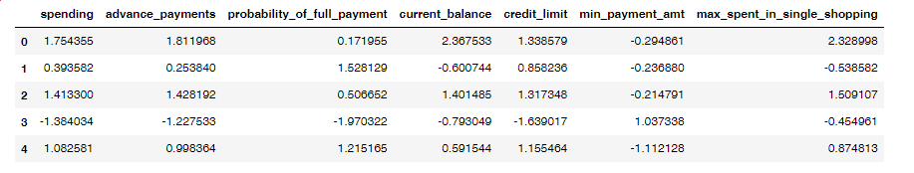
Table 1.4 Scaled Data

Apply hierarchical clustering to scaled data. Identify the number of optimum clusters using Dendrogram and briefly describe them
Hierarchical Clustering is the bottom up approach starts with each object forming a separate group. It keeps in merging the objects the groups that are close to one another based on the distance between the records and distance between the clusters. As there will be more than one cluster the linkage methods will be used to have proper grouping between the records. In this given dataset WARDS Linkage method is being used for clustering purpose. The wards method merges records together with the centroid and calculate with in the cluster variance. In this process it performs successive clustering steps so as to minimize the increase in Error Sum of Squares at each step.
Below is the dendrogram that has been obtained with the wards linkage method:
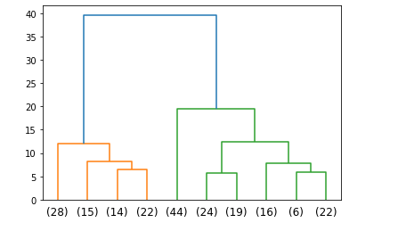
Fig 1.5 Dendrogram
From the above dendrogram it is observed that, when cutting the dendrogram at a distance of 16 we get three suitable clusters. By applying the fcluster to the dendrogram we get the following results:
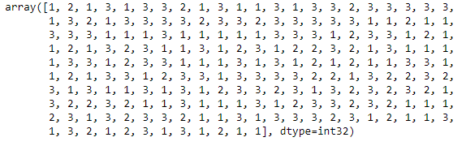
Fig 1.6 Ward Linkage with Maxclust 3

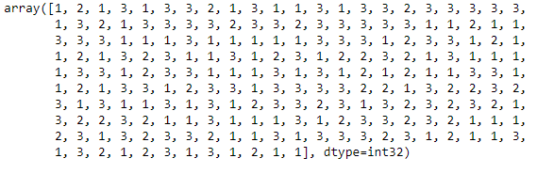
Fig 1.7 Ward Linkage with distance 16
After grouping the dataset into clusters the record wise clusters are shown as below:
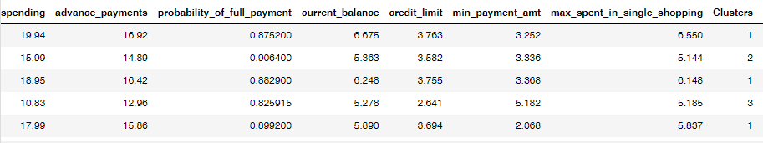
Table 1.5 Sample Cluster Dataset

Cluster Grouping:
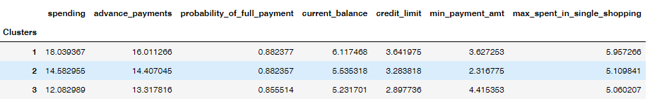
Table 1.6 Grouping the Clusters
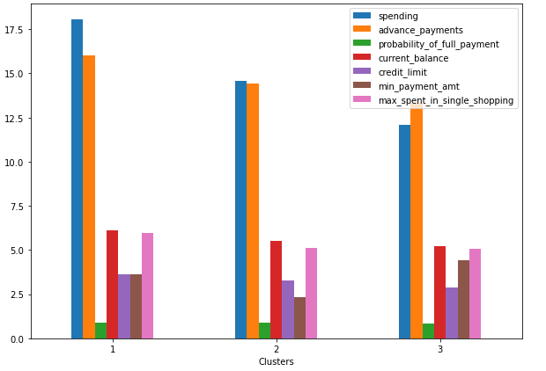
Fig 1.8 Cluster analysis
From the above grouping is the analysis is as follows:
Cluster 1: High spending customers
Cluster 2: Medium Spending Clusters
Cluster 3: Low spending Clusters
- Minimum amount paid is higher in the cluster 3 compared to cluster 1 and 2.
- The mean of Maximum spent in single shopping is almost same across all the clusters
- There is no major difference in the credit limit in cluster 1 and cluster 2.
- The probability of full payment stands at 80% in all three clusters
- Current balance in cluster 1 is high compared to other two clusters
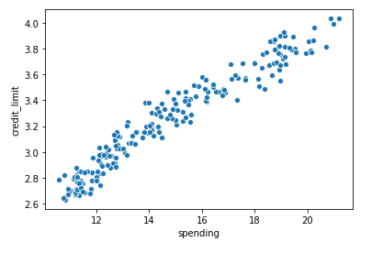
There is absolutely positive correlation between spending and Credit card limit and there is enough evidence that credit limit is higher against the cluster 2 spending
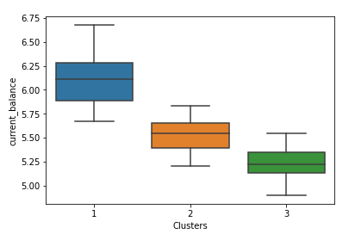
The median current balance is in all three clusters lies almost near to the second quartile (50%)

Apply K-Means clustering on scaled data and determine optimum clusters. Apply elbow curve and silhouette score. Explain the results properly. Interpret and write inferences on the finalized clusters.

It is a non-hierarchical clustering approach where we specify the number of clusters needed as output. In order to identify the number of clusters required to get the output we use the elbow curve technique or WSS (within the sum of squares) to determine the no.of clusters to be used.
For clusters = 1,2,3,4,5,6 the K means inertia values to determine the optimum number of clusters is as follows:
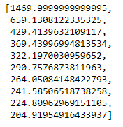
Table 1.7 K means Inertia values
From the above table of figure we get an elbow curve as below:
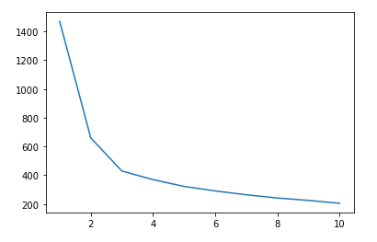
Fig 1.9 Elbow Curve
From the elbow curve we can evidently say there the optimum no.of clusters is 3 as after 3 there is no sharp decrease in the curve.
Cluster Analysis:
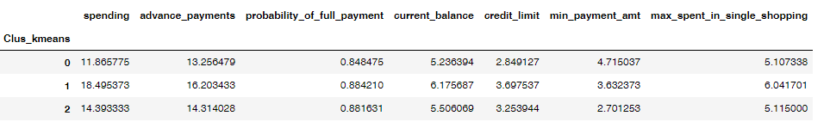
Table 1.8 K means Cluster Grouping
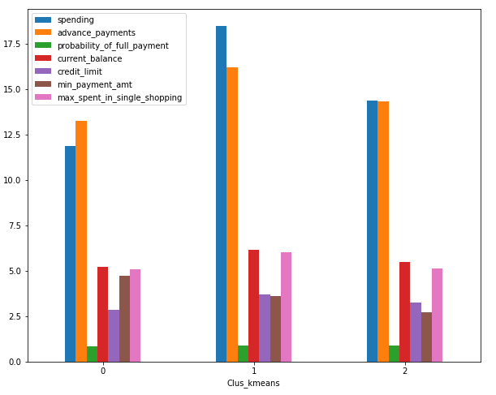
Fig 1.10 K means Cluster Graph

From the above grouping is the analysis is as follows:
Cluster 0: Low spending customers
Cluster 1: High Spending Clusters
Cluster 2: Medium spending Clusters
- Minimum amount paid is higher in the cluster 0 compared to cluster 1 and 2.
- The mean of Maximum spent in single shopping is high in cluster 1 as compared to other cluster 0 and cluster 2.
- There is no major difference in the credit limit in cluster 1 and cluster 2.
- The probability of full payment stands at 80% in all three clusters
- Current balance in cluster 1 is more compared to other two clusters

Describe cluster profiles for the clusters defined. Recommend different promotional strategies for different clusters.

Cluster Profiles: In this particular dataset we are doing the cluster profiling based on the hierarchical clustering.
Cluster 1: High Spending Group
Cluster 2: Medium Spending Group
Cluster 3: Low Spending Group

Promotional Strategies for different clusters:
Cluster 1:
- As maximum spending is high for this group coupons/cashbacks can be given which inturn can also increase their spending.
- Credit Card limit for cluster 1 can be increased as the advance payments, minimum payment amount and current balance is also high is high in this case.
- Can provide EMI options and loans can also be given these customers

Cluster 2:
- Cash back offers can be made to increase the minimum payment amount
- This group is potential customers who can reach the cluster 1 if the more offers can be given to increase the spending.
- As the probability of payment is high zero % interest EMI and can be provided on the high end goods like ACs, TVs etc
- Can offer cash backs on transactions to increase the spending through cards
Cluster 3:
- As the minimum payment is high credit limit may be increased
- Can be given more benefits on proving the different bonus cards, shopping cards etc.,
- Can be given discounts on medium daily goods.

Project 2: CART-RF-ANN

Problem Statement
An Insurance firm providing tour insurance is facing higher claim frequency. The management decides to collect data from the past few years. You are assigned the task to make a model which predicts the claim status and provide recommendations to management. Use CART, RF & ANN and compare the models' performances in train and test sets.

Introduction:
The purpose of this assignment is to understand the claim status to provide accurate recommendations to management by performing required exploratory data analysis and CART-RF-ANN Models. By performing these 3 models will help us to identify the model is predicting the accurate claim status.

2.1 Read the data, do the necessary initial steps, and exploratory data analysis (Univariate, Bi-variate, and multivariate analysis).

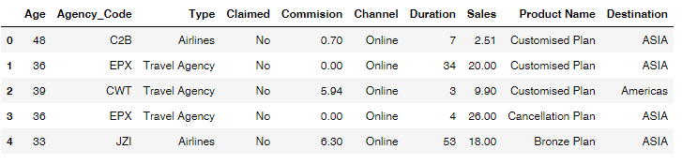
Table 2.1 Sample Dataset
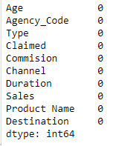
Table 2.2 Null Values
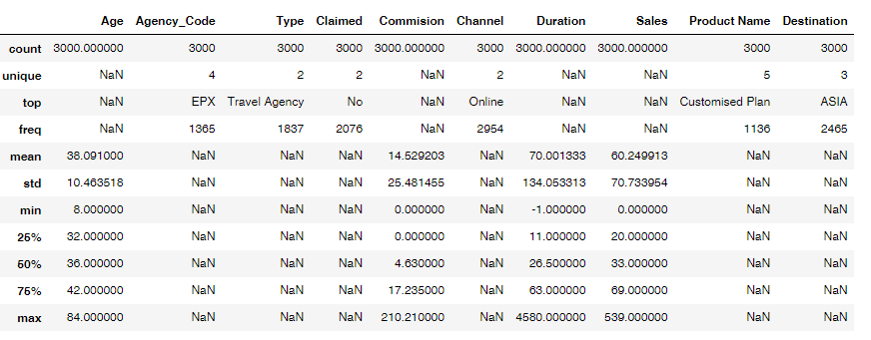
Table 2.3 Data Description
The dataset contains 3000 observations with 10 features
The dataset contains no missing values.
Data have duplicated values of 139 rows but those values have similar categorical entries in this case the duplicated values should not be removed
The minimum probability of making the full payment stands at 0.80 which is a positive attribute for the bank
It is observed the minimum commission received for travel agency is 0 while the maximum commission received is 210.
The minimum duration of the tour value is in negative i.e., -1 while the maximum is 4580
The minimum age of insured is 8 and the maximum is 84
Univariate Analysis:
- There are 4 numeric fields in the data
- Insured age ranges from 8 years to 84 years
- Only few customers have gross income more than 30L
- Average age of an insured is 38 is 0.42
- Outliers existed
- There are 6 categorical features
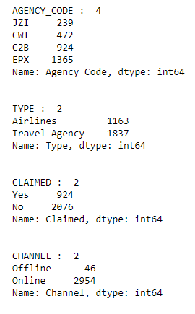
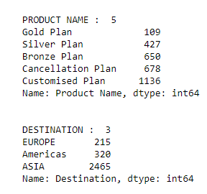

There are 4 Agency codes with 2 distribution channels with online and offline variables. Online distribution channel is having a high frequency than offline distribution channel.
There are 5 insurance products with most no.of insurers opted for customized plan.
Only 924 customers out of 3000 have claimed the insurance

Outliers:
Outliers are present in all most all the numerical variables and the categorical variables. In this particular problems the outliers are not being treated as there will be not much impact on the model predictions
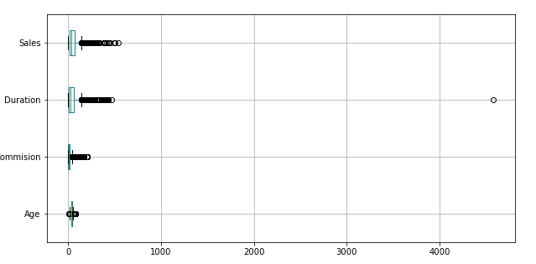
Fig 2.1 Outliers

Bivariate Analysis:
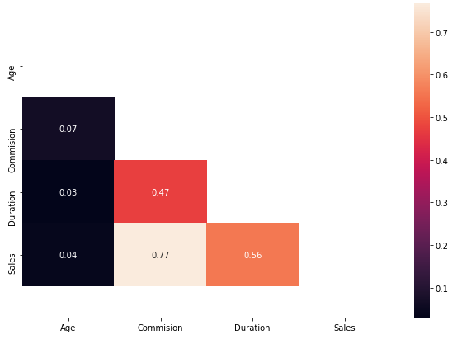
Fig 2.2 Correlation Graph
From the above correlation analysis there is no good correlation among the variables. We may say that all the features are dependent to each other.

Multivariate Analysis:
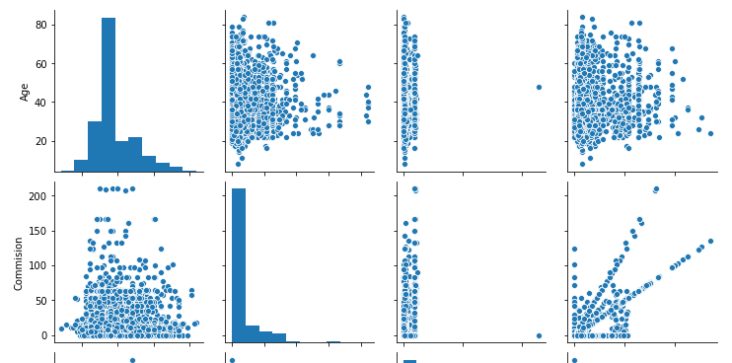
Fig 2.3 Sample Pair plot
From the above pair plot only commission and sales are showing little correlation and other features doesn’t have any relation among variables.
There is no class imbalance with 0,s and 1,s ratio of 69:30.
For any data to be modeled the data categorical variables i.,e object type data needs to be converted into the codes. The dataset after converting the codes is as below:
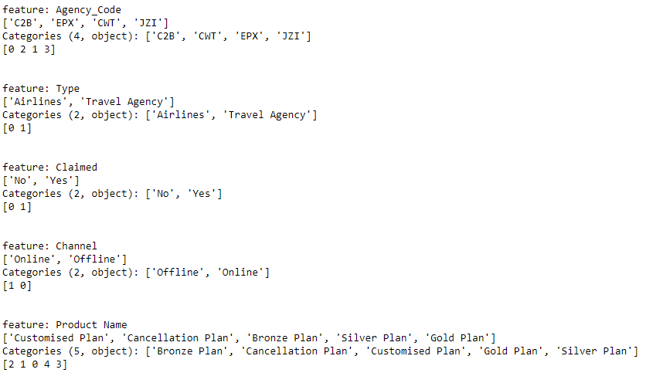

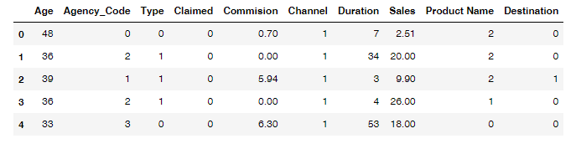
Table 2.4 Sample Dataset after assigning feature codes

2.2 Data Split: Split the data into test and train, build classification model CART, Random Forest, Artificial Neural Network
From the dataset the train and test data is divided into two subsets with 70:30 ratio.
- Train Dataset: Used to fit machine learning model
- Test Dataset: Used to evaluate the fit machine learning model.
- The train test data is basically used when the dataset is large.
Below is the train test data from the dataset:
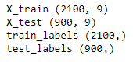
Classification Models: Through the Grid Search technique the python has identified the best possible classifiers for CART Model as below:
CART Model:
- DecisionTreeClassifier(max_depth=4, min_samples_leaf=40, min_samples_split=250)
Random Forest Model:
- RandomForestClassifier(max_depth=6, max_features=3, min_samples_leaf=10, min_samples_split=50, n_estimators=350)
Artificial Neural Networks:
- MLPClassifier(hidden_layer_sizes=200, max_iter=2500, tol=0.01)

2.3 Performance Metrics: Comment and Check the performance of Predictions on Train and Test sets using Accuracy, Confusion Matrix, Plot ROC curve and get ROC_AUC score, classification reports for each model.

CART Model Evaluation:
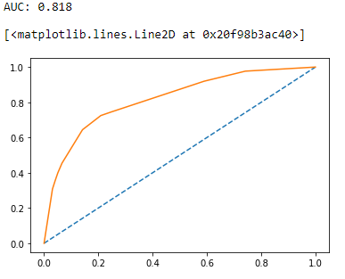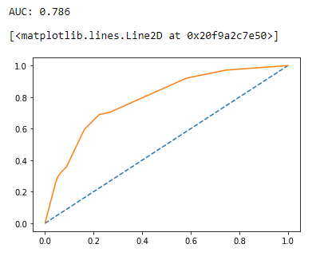
Fig 2.4 CART Train curve Fig 2.5 CART Test curve
CART Confusion Matrix

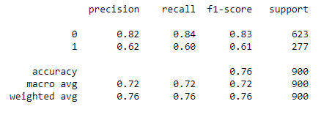
Table 2.5 : CART Train classification report
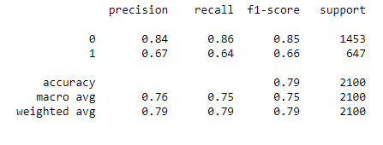
Table 2.6: CART Test classification report
CART Conclusion:
Train Data: AUC: 81.8% Accuracy: 79.2% Sensitivity: 64% Precision: 67% f1-Score: 66%
Test Data: AUC: 78.6% Accuracy: 76.3% Sensitivity: 60% Precision: 62% f1-Score: 61%
Training and Test set results are almost similar, and with the overall measures high, the model is a good model.
Random Forest Model Evaluation:

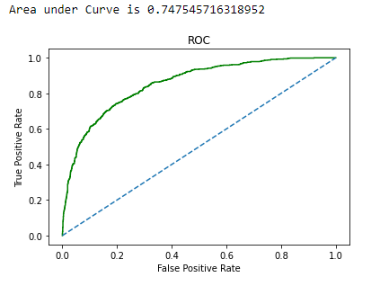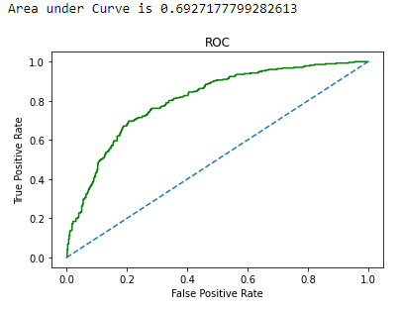
Fig 2.6 RF Train curve Fig 2.7 RF Test curve

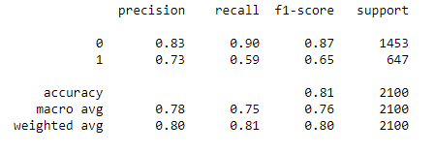
Table 2.7: RF Train Confusion matrix

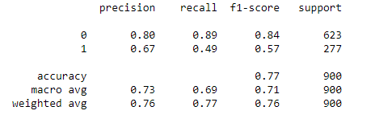
Table 2.8: RF Test Confusion Matrix

RF Conclusion:
Train Data: AUC: 74.5% Accuracy: 81% Sensitivity: 59% Precision: 73% f1-Score: 65%
Test Data: AUC: 69.2% Accuracy: 77% Sensitivity: 49% Precision: 67% f1-Score: 57%
Training and Test set results are almost similar, and with the overall measures high, the model is a good model.

ANN Model Evaluation:

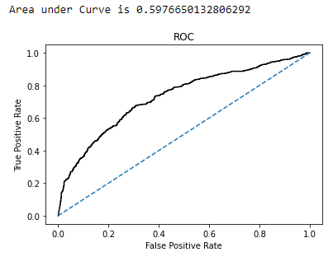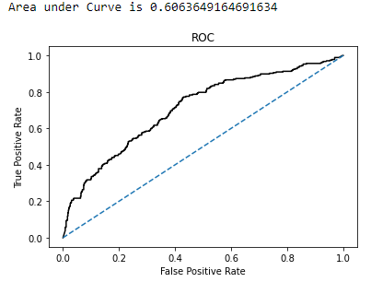
Fig 2.8 ANN Train curve Fig 2.9 ANN Test curve

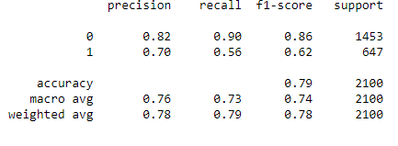
Table 2.9: ANN Train Confusion matrix

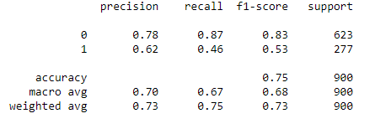
Table 2.10: ANN Test Confusion matrix

ANN Conclusion:
Train Data: AUC: 59.7% Accuracy: 79% Sensitivity: 56% Precision: 70% f1-Score: 62%
Test Data: AUC: 60% Accuracy: 75% Sensitivity: 46% Precision: 62% f1-Score: 53%
Training and Test set results are almost similar, and with the overall measures high, the model is a good model.

2.4 Final Model: Compare all the models and write an inference which model is best/optimized.

The comparison table of three models is shown below:
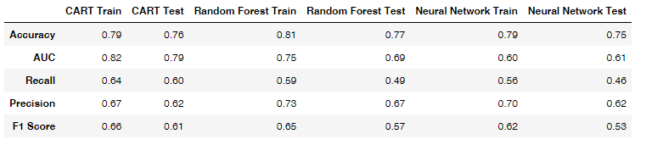
Table 2.11: Comparison table with three models
From the given business problem it is quite clear that we need to look for accuracy and precision values as the entire business problem depends on the False Positives (Type I error). If the precision value is high then we can reduce the Type I error as precision is inversely proportional to Type I error.
From the above table the precision value for is high for Random Forest Train data and also th3 accuracy is high the random forest model. So to reduce the Type I error which is an important measure to determine the accurate prediction we can choose the Random Forest to understand the Claim Status.
Hence, the Random Forest is the clear winner in this case because of the best accuracy % and reasonable deviations.

2.5 Inference: Based on the whole Analysis, what are the business insights and recommendations.

The data seems to be more include towards particular variables compared to the other variables like claimed Vs not claimed ratio is 90:10 ratio.
There are 10 variables in the dataset to determine the claim status but if there are more no.of features to get the accuracy in the claim status prediction.
Agencies can increase the online distribution channel to increase the business.
More features can be included in the insurance policy that customers will able to customize the plans as the more customers are customization plan in the insurance policy.
Most customers preferred destination tour as ASIA, so the commission by the Agency may be reduced for this particular route for the customers. More benefits may be given to customers to purchase the plans.
For Europe and America destinations, Agencies can provide premium insurance plans for customers. Along with the plans few additional benefits of purchase discounts on stays etc may be given.
Agency JZI can focus on to increase its ferequcy by comparing plans with the EPX and may offer more benefitted plans for customers.
Over all we need to understand the business structure more will more data that can determine the claim status.

